Advertising bonus
31/01/2024
MILAN
Via Visconti di Modrone, 38 - 20122 Milan
Tel: (39) 02 76.02.15.14
Fax: (39) 02 78.05.13
E-mail: info@studionicolini.com
Fiscal code and VAT number 09910630152

NEWSLETTER
INFORMATION LETTER N.05/2024

INFORMATION LETTER N.05/2024
Disegno di Legge “Capitali”
Advertising bonus

In order to benefit from the tax credit for advertising investments made in 2023, subjects that have submitted the preliminary communication for accessing the incentive should submit - by February 9th 2024 - a specific substitute declaration to confirm the “reservation” .

In general, it is reminded that the following subjects are eligible for the tax credit:

- companies (regardless of legal form, size and accounting regime adopted);
- self-employed workers (including regulated professions);
- non-commercial entities.

The substitute declaration form should be submitted electronically, through the dedicated procedure available in the reserved area section of the Tax Authority’s website.

- Amount of the tax credit
The tax credit is granted at a rate of 75% of the incremental value of investments made in advertising campaigns, exclusively in daily and periodical print media, including on-line, up to a maximum expenditure of € 30 million per year, if there is a minimum increase of 1% in advertising investments, compared to the previous year.

- Utilization method of the tax credit
The tax credit actually available to each applicant will be subsequently determined by a specific measure of the Department for Information and Publishing, which will be published on the institutional website of the Department itself.

The recognized tax credit can be used only for offsetting, through form F24 (tax code “6900”), to be submitted via the Tax Authority’s electronic services starting from the fifth working day following the publication of the list of eligible subjects.

° ° °

Our Firm remains at disposal for any further clarification.

Studio Nicolini Commercialisti Associati
Milan, 31 January 2024

The information contained in this Information letter has a mere general and informative scope and does not constitute an advice on the subjects covered.
Our Firm remains at complete disposal for any additional information.
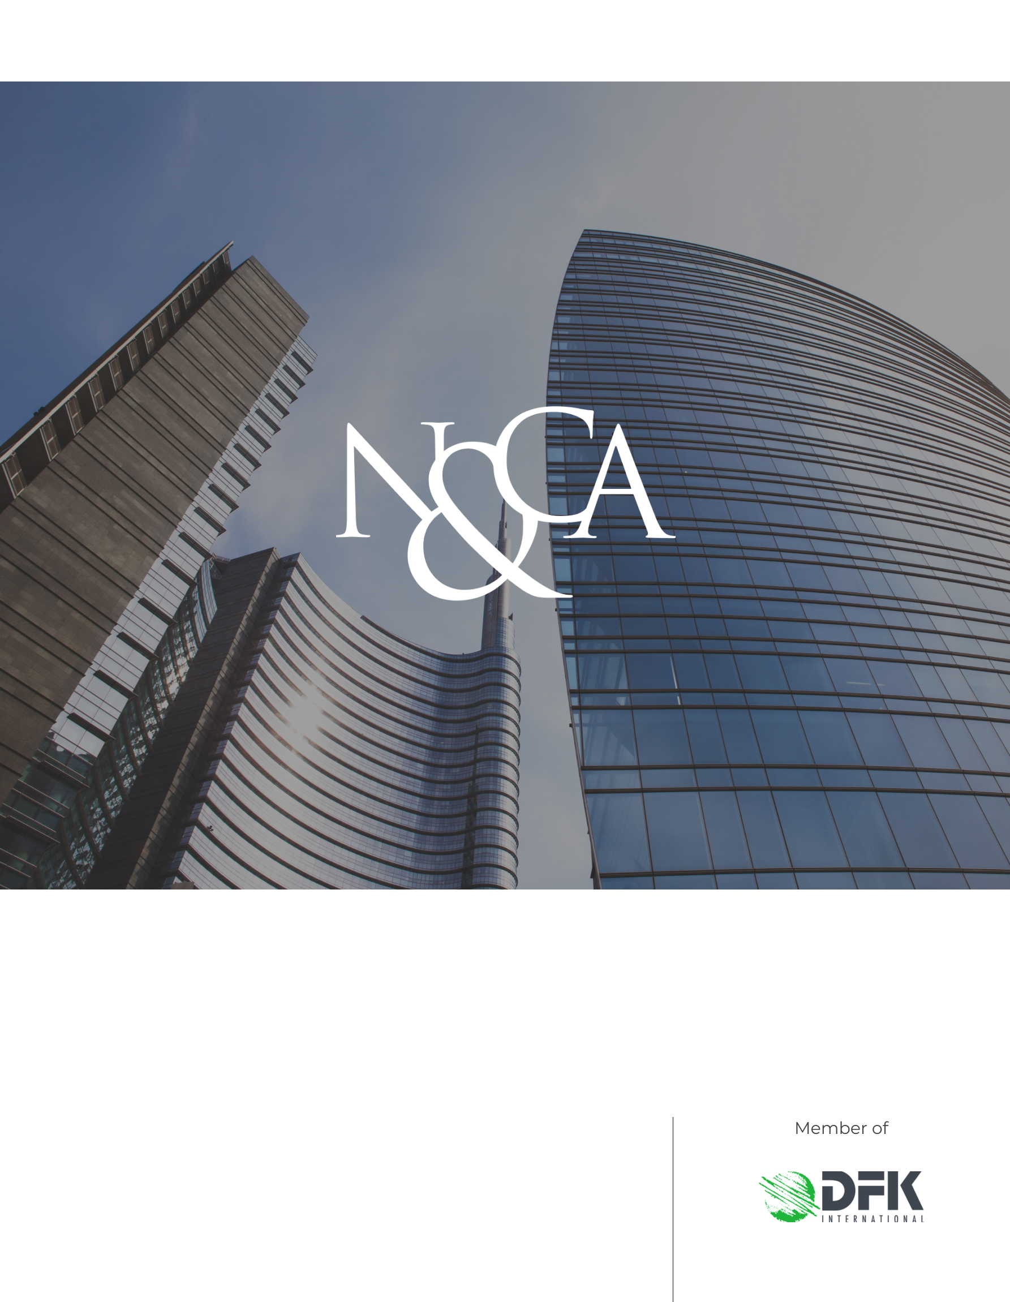
www.studionicolini.com
MILAN
Via Visconti di Modrone, 38 - 20122 Milan
Tel: (39) 02 76.02.15.14
Fax: (39) 02 78.05.13
E-mail: info@studionicolini.com
Fiscal code and VAT number 09910630152

The instructions for completing the form and the website of the Italian Tax Authority, indeed, provide that the substitute declaration regarding the investments made should be submitted by February 9 of the subsequent year following the reference year of the incentive (for which the communication for access has been submitted); for the year 2023, the communication should have been submitted in March 2023.
Under section "Servizi per”, in the item "Comunicare”, accessible with the Public Digital Identity System (SPID), National Services Card (CNS) or Electronic Identity Card (CIE).
Advertising investments made on television and radio broadcasters, analog or digital, are no longer eligible for the incentive.
The incentive is granted, however, in compliance with the de minimis regime.

