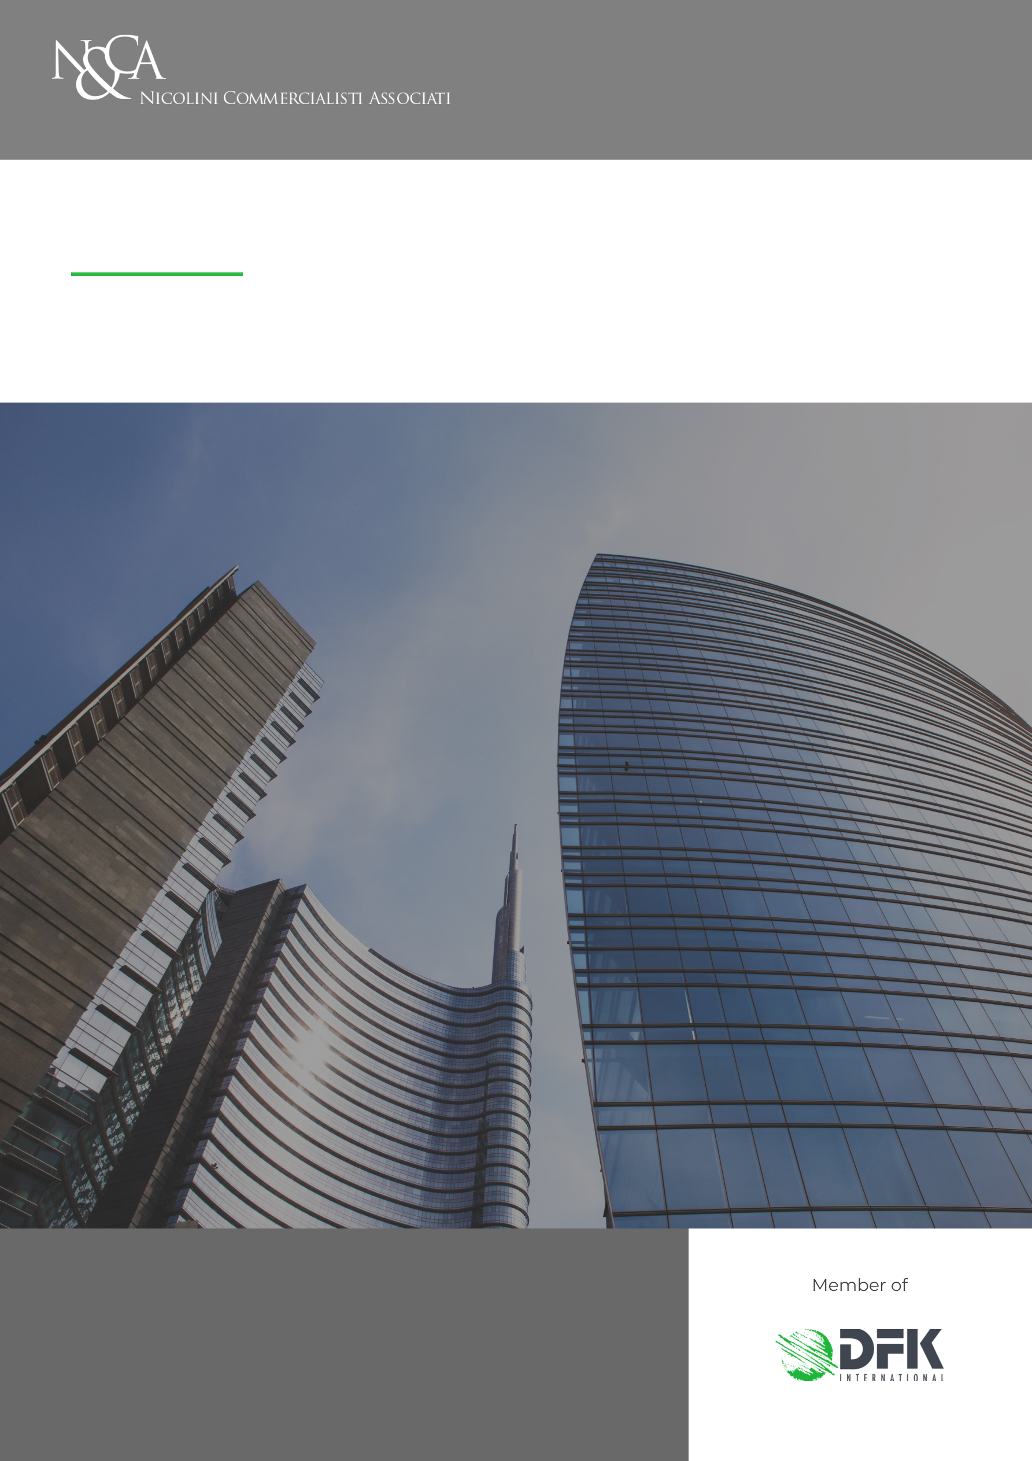
Catastrophic risk insurance
5/02/2024
MILAN
Via Visconti di Modrone, 38 - 20122 Milan
Tel: (39) 02 76.02.15.14
Fax: (39) 02 78.05.13
E-mail: info@studionicolini.com
Fiscal code and VAT number 09910630152

NEWSLETTER
INFORMATION LETTER N.06/2024

INFORMATION LETTER N.06/2024
Disegno di Legge “Capitali”
Catastrophic risk insurance

Article 1, paragraphs 101 - 111, of the 2024 Budget Law has introduced the obligation for companies, to be fulfilled by December 31st 2024, to subscribe to an insurance for protection against catastrophic risks.
Such provision aims at providing economic relief to companies with headquarters in Italy in the event of catastrophic events causing damages to population, businesses and infrastructures, with the objective of shifting risks of such events and related costs not only onto the Government (which assumes the role of co-insurer), but also onto private entities.

The obligation to sign the insurance concerns, specifically, companies headquartered in Italy and those with registered office abroad but with a permanent establishment in Italy, enrolled in the Business Registry.

Are, however, excluded:

- agricultural businesses (according to article 2135 of the Civil Code), for which the National mutual fund for coverage of catastrophic damages applies, established by Law 234/2021;
- companies whose real estate assets are burdened by building abuses or constructed without authorizations, or burdened by abuses occurring after the construction.

Interested subjects are required to subscribe, by December 31st 2024, to insurance contracts for damages related to assets listed in section “Attivo”, item “B-II”, n.1, 2 and 3: land and buildings, plants and machinery, industrial and commercial equipment.

The insurance policy is mandatory and non-compliance should be taken into account in the allocation of contributions, subsidies or financial benefits using public resources, including those provided in the event of catastrophic events.

In return for subscribing to the agreement, insurance companies will be required to apply:

- an eventual deductible not exceeding 15% of damages;
- premiums proportional to risks.

A specific Decree from the Ministry of Economy and Finance and the Ministry of Made in Italy will define the implementing criteria of the a/m insurance, as well as the procedures for identifying calamitous and catastrophic events eligible for compensation, determining and periodically adjusting premiums and updating deductible values.

° ° °

Our Firm remains at disposal for any further clarification.

Studio Nicolini Commercialisti Associati
Milan, 5 February 2024

The information contained in this Information letter has a mere general and informative scope and does not constitute an advice on the subjects covered.
Our Firm remains at complete disposal for any additional information.
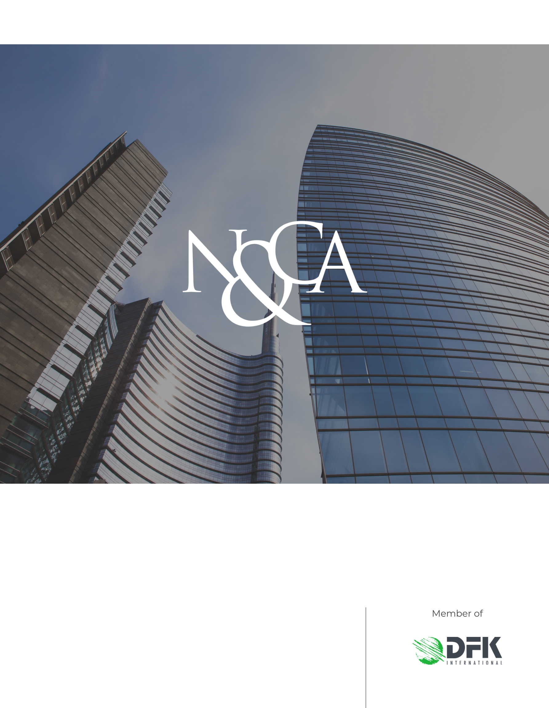
www.studionicolini.com
MILAN
Via Visconti di Modrone, 38 - 20122 Milan
Tel: (39) 02 76.02.15.14
Fax: (39) 02 78.05.13
E-mail: info@studionicolini.com
Fiscal code and VAT number 09910630152

Such insurance contracts should be intended to cover damages directly caused by natural disasters and catastrophic events occurring within the national territory. The regulation specifies the type of damage event qualifying as insurable loss, listing earthquakes, floods, landslides, inundations and overflow events.
Insurance companies are obliged to enter into such contracts and, if they refuse, even upon renewal, they are subject to administrative fines ranging from € 100.000 to € 500.000, imposed by IVASS.

