Decree on tax compliance
15/02/2024
MILAN
Via Visconti di Modrone, 38 - 20122 Milan
Tel: (39) 02 76.02.15.14
Fax: (39) 02 78.05.13
E-mail: info@studionicolini.com
Fiscal code and VAT number 09910630152

NEWSLETTER
INFORMATION LETTER N.07/2024

INFORMATION LETTER N.07/2024
Disegno di Legge “Capitali”
Decree on tax compliance

On January 8th 2024, the Legislative Decree n.1 (published in the Official Gazette on January 12th 2024) was approved, introducing various innovations aiming at simplifying tax compliance.

Here below, the most significant updates contained in the a/m Decree are reported.

- Deadline for filing income tax and Irap returns (art.11)
Article 11 anticipates to September 30th the deadline for filing income tax and Irap returns; therefore, the deadline is moved up to the ninth month following the end of the tax period.

It is also provided that, starting from 2025, tax returns can be submitted from April 1st of each year.

- Modification of installment payments (art.8)
The Decree on tax compliance modifies the installment payment terms of tax amounts due as final and first installment, starting from the payments relating to the 2023 tax year.
In particular, the deadline for installment payments is standardized to the 16th of each month, formerly differed between VAT holders (16th of each month) and non-VAT holders (month end), with the introduction of the possibility of an additional installment, due on December 16th .

- Minimum VAT and withholding tax payments (art.9)
Article 9 of the Decree updates the minimum amounts for VAT payments, increasing the minimum threshold to € 100,00; below this limit, payments are deferred to the following month/quarter.
Starting from payments of January 2024, the threshold for paying withholding taxes on self-employment income, miscellaneous income and provisions also increases to € 100,00: in case of withholding taxes below this threshold, payments can be made cumulatively with those of the following month and, in any case, by December 16th of each year.

- Reduction of penalties for non-use of cash (art.15)
In order to access the benefit of a 50% reduction in penalties for taxpayers who only make traceable payments, it is no longer required to indicate in the tax return the details of the bank accounts used for receipts/payments.

It is highlighted that such benefit is granted to entities, artists or professionals, with revenues or turnover not exceeding € 5 million who - for all active and passive transactions carried out in running the business - exclusively use payment instruments other than cash.

- New features for ISA subjects (arts.5, 6, 7, 14)
For the 2023 tax year, programs for calculating the so-called “Indici Sintetici di Affidabilità” (synthetic reliability indexes) should be made available by April 30th 2024, while in the long term (starting from the 2024 tax period) they should be available by March 15th of the following year.

Furthermore, limits within which tax credits can be offset without the need for compliance approval (“visto di conformità”) are increased for taxpayers who achieve minimum scores (which vary from year to year) associated with index incentives.

The thresholds change:

- from € 50.000 to € 70.000 annually for offsetting VAT credits;
- from € 20.000 to € 50.000 annually for offsetting direct taxes or Irap credits.

- Elimination of the obligation of certifications (art.9)
The a/m Decree eliminates the obligation of certifications (CU) for compensations paid to lump-sum taxpayers to whom withholding tax does not apply.
However, such novelty applies to compensations for the 2024 tax year (and, therefore, for certifications to be issued in 2025).

- Other novelties
Among the additional novelties contained in the Decree, it is also noted:

- the suspension, in the months of August and December, of the sending of friendly notices, liquidation letters for income subject to separate taxation, compliance letters and irregularity communications (art.10);
- the introduction of the possibility of using the PagoPA platform for tax, contribution and other payments now settled through F24 form (for this purpose, one or more implementing measures will need to be issued by the Tax Authority) (art.12);
- the provision, starting from tax returns relating to the 2023 tax year, that the failure to indicate the granted tax credits does not constitute a cause for forfeiture (however, regarding tax credits constituting State aid or “de minimis”, failure to register with the RNA results in the illegitimacy of the aid) (art.13);
- starting from 2024, a semi-annual filing is foreseen for the transmission to the health card system (STS) of data relating to healthcare expenses, with deadlines to be set by the Ministry of Finance (art.12);

- the introduction of a less complex procedure to communicate the termination of the appointment as depositary of accounting records by professionals who no longer assist clients who failed to notify the Tax Authority (art.4);
- the possibility, for withholding agents, to communicate data on withholding taxes for both employed and self-employed work through the services of the Tax Authority, without the need for further indication in the 770 return (art.16).

° ° °

Our Firm remains at disposal for any further clarification.

Studio Nicolini Commercialisti Associati
Milan, 15 February 2024

The information contained in this Information letter has a mere general and informative scope and does not constitute an advice on the subjects covered.
Our Firm remains at complete disposal for any additional information.
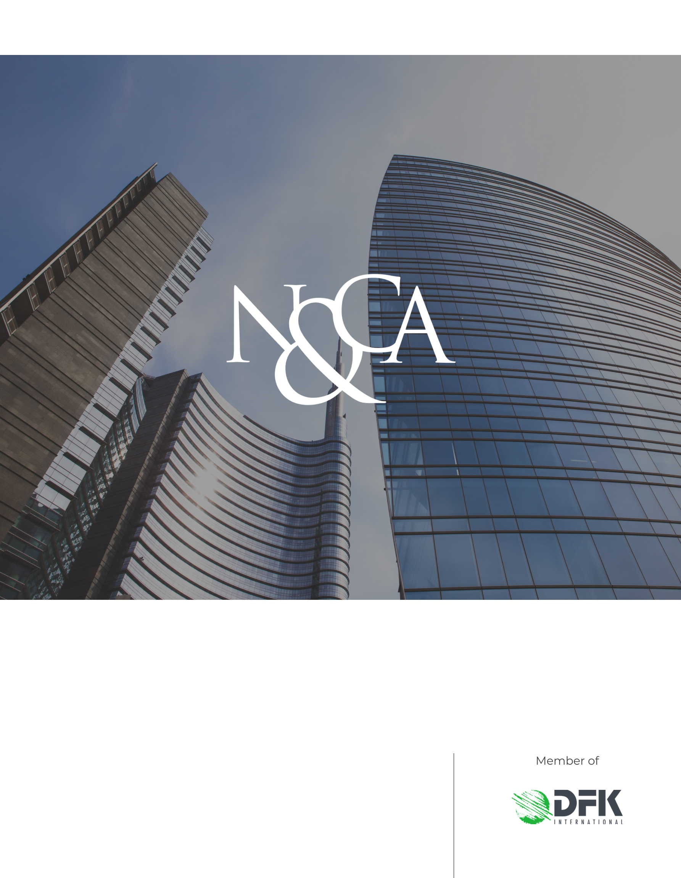
www.studionicolini.com
MILAN
Via Visconti di Modrone, 38 - 20122 Milan
Tel: (39) 02 76.02.15.14
Fax: (39) 02 78.05.13
E-mail: info@studionicolini.com
Fiscal code and VAT number 09910630152

Such changes come into effect on May 2nd 2024 and, therefore, taxpayers with calendar year should submit their tax returns, for the 2023 tax year, no later than September 30th 2024. However, for the 2023 tax period only, the deadline is deferred to October 15th 2024, according to the text of the “Decreto accertamento e concordato preventivo biennale” currently being published.
Moreover, the obligation to exercise the option for installment payments in the tax return is abolished.
No changes have been introduced to the benefit for those making traceable payments exceeding € 500, which requires the indication in the RS section of the income tax return, also granted to taxpayers with revenues/turnover exceeding € 5 million. In such a case, assessment terms decrease by two years and therefore expire on December 31st of the third year following the filing of the tax return.
The exemption is accompanied by the elimination of the option to issue paper invoices for lump-sum taxpayers with revenues below € 25.000: starting from January 1st 2024, in fact, the obligation to issue electronic invoices applies to all lump-sum taxpayers, regardless of turnover.

